

Ajeevika

Buyer App User Manual

|  |
| --- |
|  |
|  |
| Buyer User Manual  By Kamtech Associates |

Contents

Section 1: General Information 3

Getting Started 4

1.1. Application Overview 4

1.2. Hardware and Software Requirements 4

1.3. User Access Levels 4

1.4. Purpose of the document 4

1.5. Disclaimer 5

1.6. Downloading Application (for demonstration purpose) 5

1.7. Opening Application 6

2. User, Accounts & Profile 7

2.1. Sign Up 7

2.2. Login & Logout 8

2.3. Forget Password 9

2.4. Profile 10

2.5. Overview of Home Page 11

Section 3: Products & Sellers 12

3.1. Browse Products 12

3.2. Product Page 14

3.3. Express Interest 15

3.4. My Orders 17

3.5. Seller Profile 18

3.6. Ratings and Reviews 18

Section 4. Other Features 19

3.7. Grievances 19

3.8. Ratings Orders 20

3.9. Notifications 21

# 

# Section 1: General Information

# Getting Started

## Application Overview

“Ajeevika Buyer” is a is a web platform and android mobile app for the end users (citizens), to enable them to buy products (like Farm produce, Fruits, Vegetables, Dairy, Raw material and handloom) from SHG Enterprise, CLF, Saras Center and Growth Center.

## Hardware and Software Requirements

* Requires a smart phone with Android operating system (OS) minimum Android version should be 9.0 and above.
* To download and use the functionalities of Ajeevika mobile app, you require an Internet connection in your mobile.
* An active email account.

## User Access Levels

There are two types of roles in Ajeevika application.

1. Guest User
2. Registered User

**1. Guest User** - Guest user is one who access and uses the application without registering in the application.

**2. Registered User**- Registered user is one who registers himself/herself in the application by filling the registration form. Registered users can express interest and actually buy products.

*\*In this manual we are going to view in terms of Registered User.*

## Purpose of the document

This document is aimed at serving as a guide for Users/Buyers on the use of the

Ajeevika Mobile App. The document can also help the district admins and

government officials in understanding of the buyer application.

## Disclaimer

The mobile app is android based and can only be installed on android devices. This document is prepared as an artifact to facilitate training on the digital product developed under "Technical support for the upgradation, enhancement of Uttarakhand Ajeevika and creation of Marketplace module".

Best effort has been put to ensure that the content of this document is in sync with the actual product, however, since software products can undergo multiple changes, hence it is not guaranteed that this document aligns with the latest product version. The creator or owner of this document does not accept any liability of any untoward repercussions arising out of the product usage or information mentioned in this document. All the rights of this document lie with the owner of the above- mentioned digital product.

## Downloading Application (for demonstration purpose)

Ajeevika application can be downloaded via Google Play Store. To download the application follow the following steps:

Step 1: Open Play Store application on your mobile by clicking on the Play Store icon as shown in the image below.

Step 2: Click on the Google Play text at the top and enter the text "Ajeevika" in the search bar. Click on the Ajeevika application icon from the search result.

Step 3: Click on the "INSTALL" button to install the application.

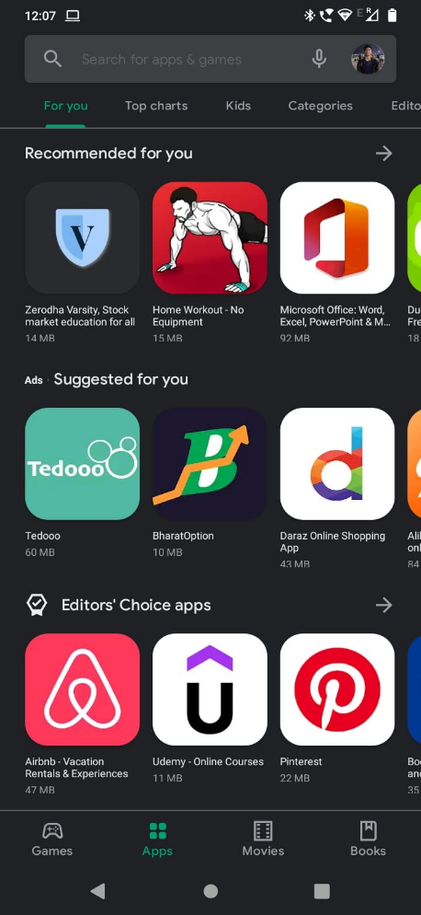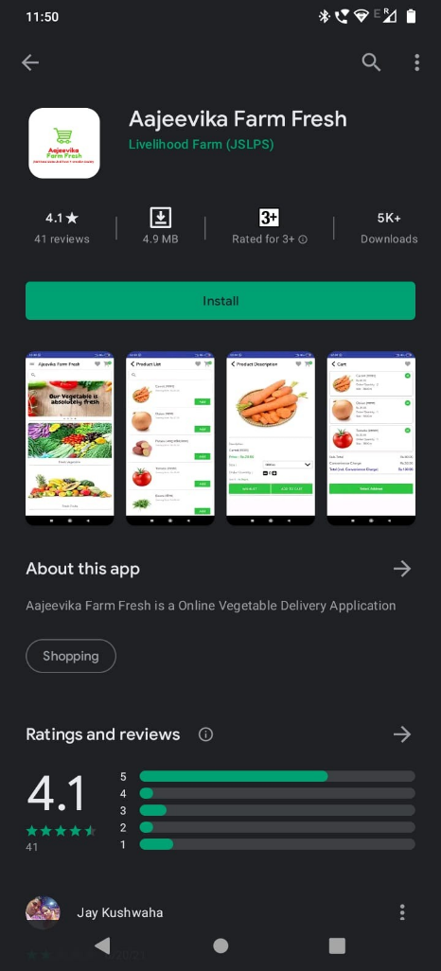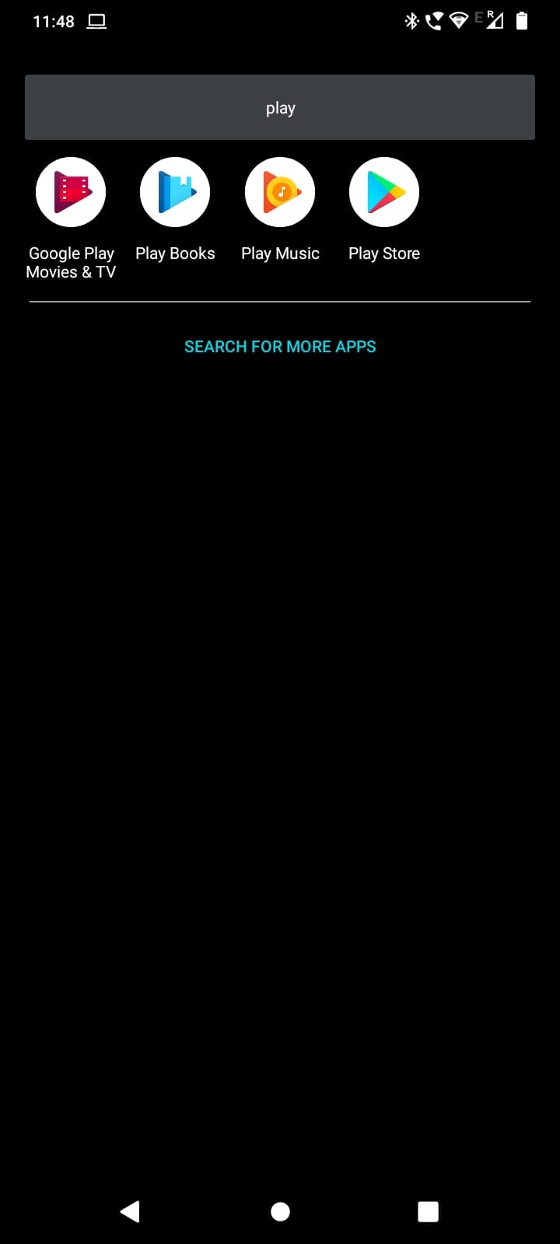

## Opening Application

Step 1: To find the application open your app drawer in android phone, and search “Ajeevika Buyer”

Step 2: Click on “Ajeevika Buyer” icon in the app drawer.

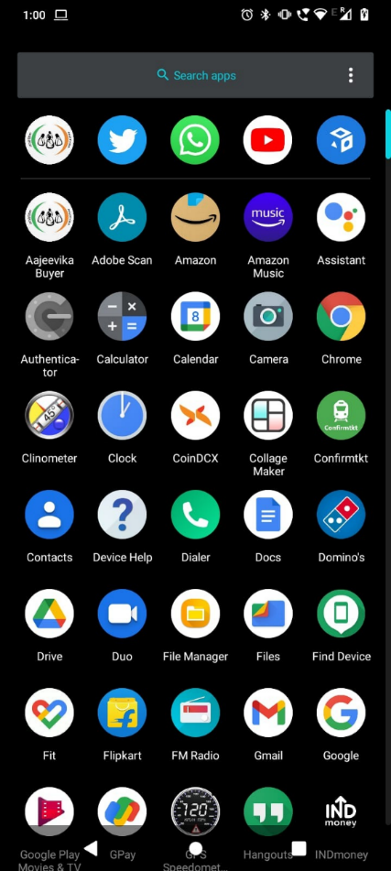

# User, Accounts & Profile

## Sign Up

When you open the application for the first time you will be greeted with the page shown below, To access the application you will need an account. To open the account follow the steps below:

Step 1: Click on “Click to Register” text on the bottom of the page.

Step 2: Fill in the required details viz a viz your Name, Email ID, Phone No., Password (should be min of 8 characters).

Step 3: After filling all the details click on Check box for T&C & Privacy Policy and click on SignUp button.

Step 4: Enter OTP, received on your registered Phone No. and click on Verify button.

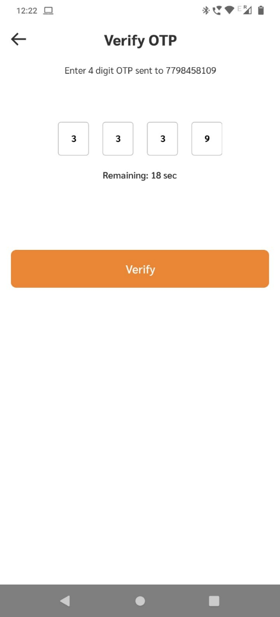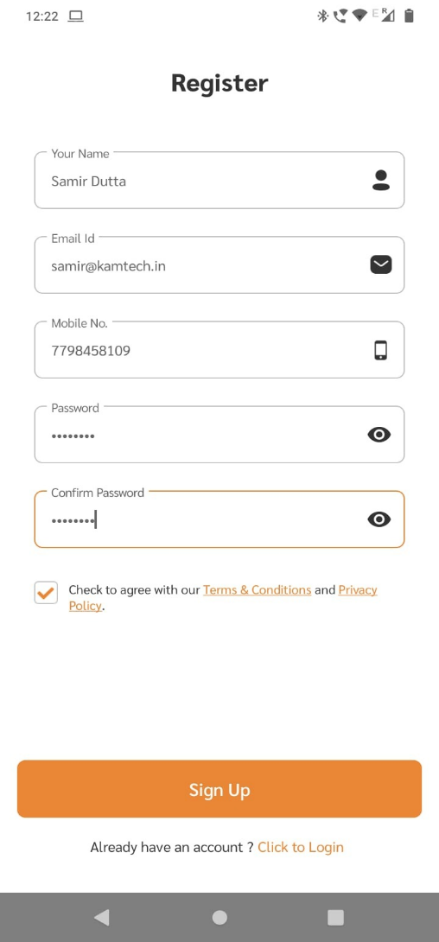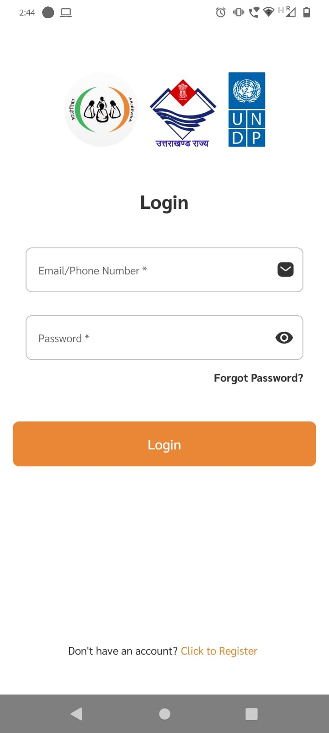

## Login & Logout

Once you create account you will be directly redirect into Home Page (which we will discuss below), but if you need to login/logout again follow the following steps:

Step 1: Open the application and enter your login credentials i.e email Id & password and click on Login button. You are successfully logged in.

Step 2: To logout click on menu button shown below, a side pane will pop up.

Step 3: Click on Logout button from the side pane.

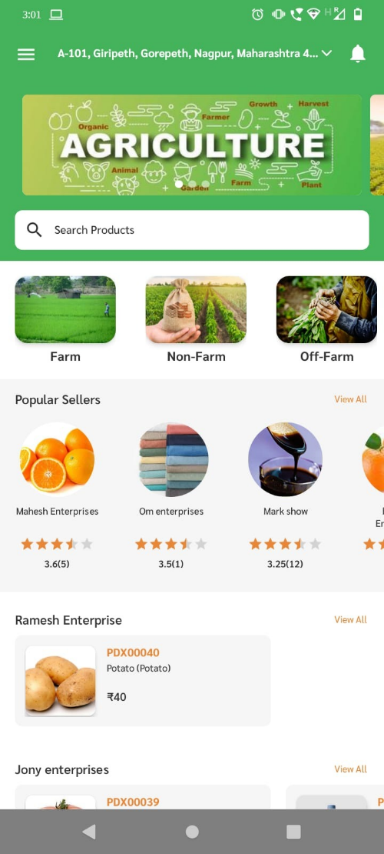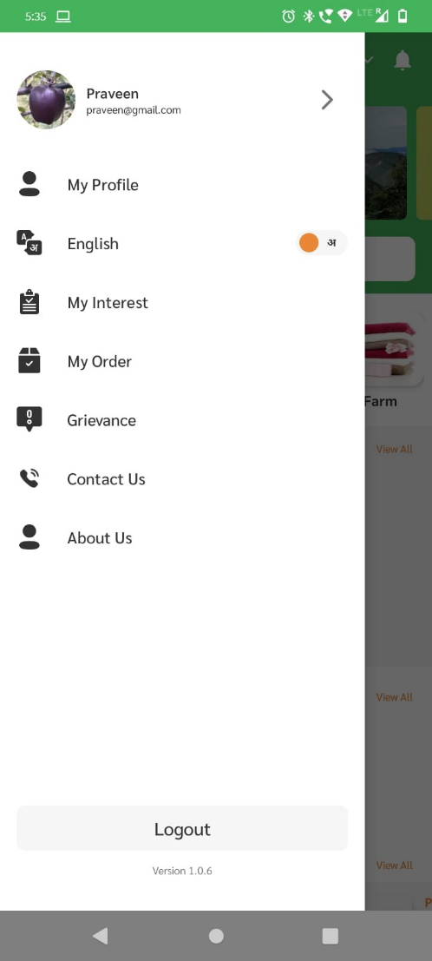

## Forget Password

If you forget your password, then don’t worry follow the following steps to change your password.

Step 1: Click on “forget password?” text shown below.

Step 2: Enter your registered mobile no. and click on Verify button

Step 3: Enter OTP received on your mobile no.

Step 4: Create new password and confirm your password and click on Save button.

Now you have successfully reset your password.

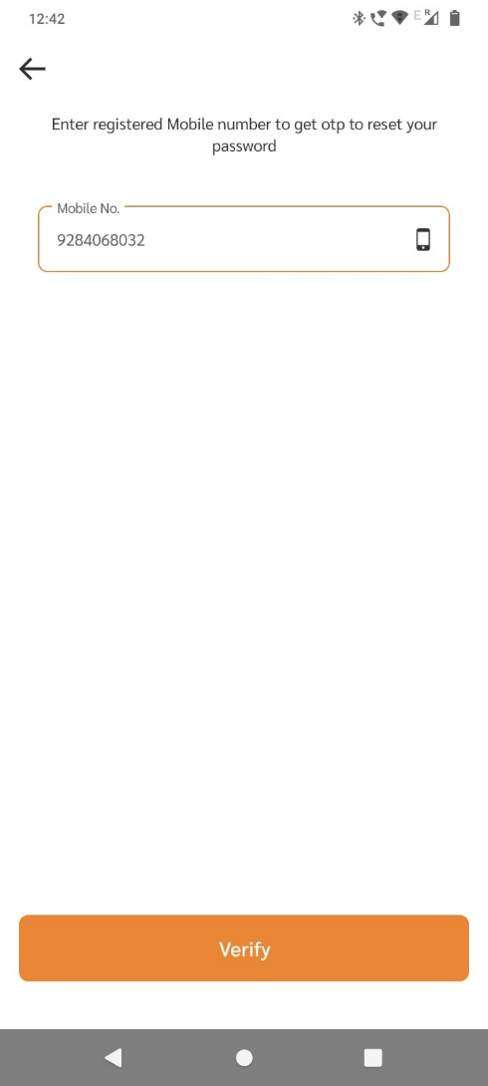

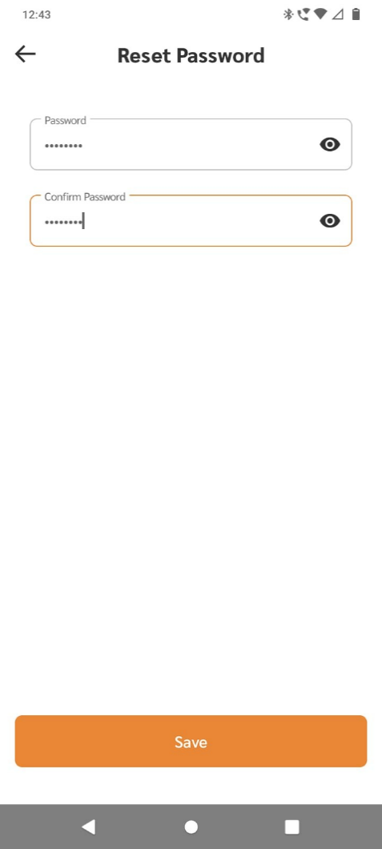

## Profile

The profile section will allow you to update user information.

Step 1: To go to profile page click on menu button and in the side-pane click on “My Profile” button.

Step 2: To update/change user information click on “Edit” button below.

Step 3: In Edit Profile, you can change your information i.e Name, Email Id and Address.

Step 4: In order to change Mobile No. you need to enter OTP sent to your new mobile no., in order to verify it.

Step 4: After making necessary changes click on “Save Changes” button.

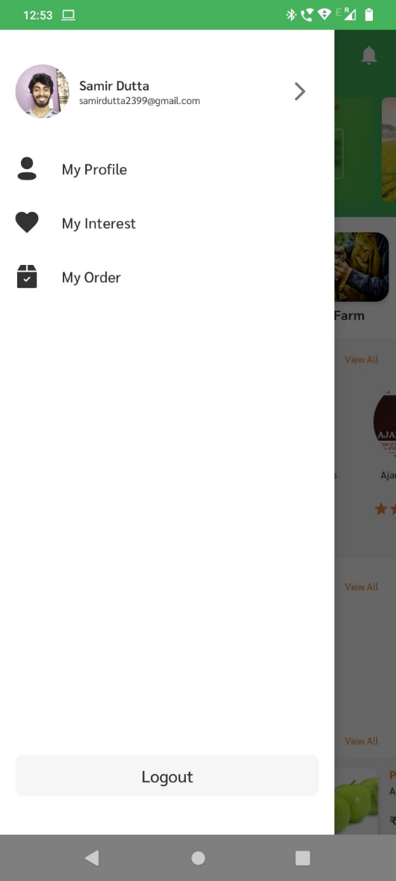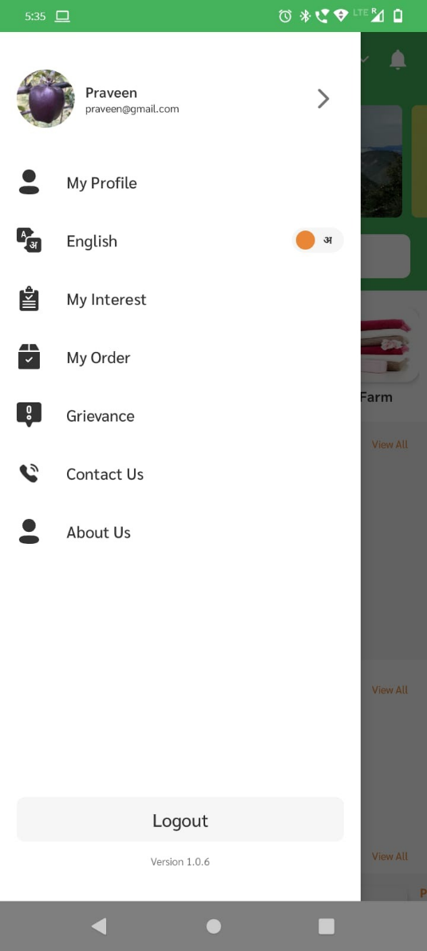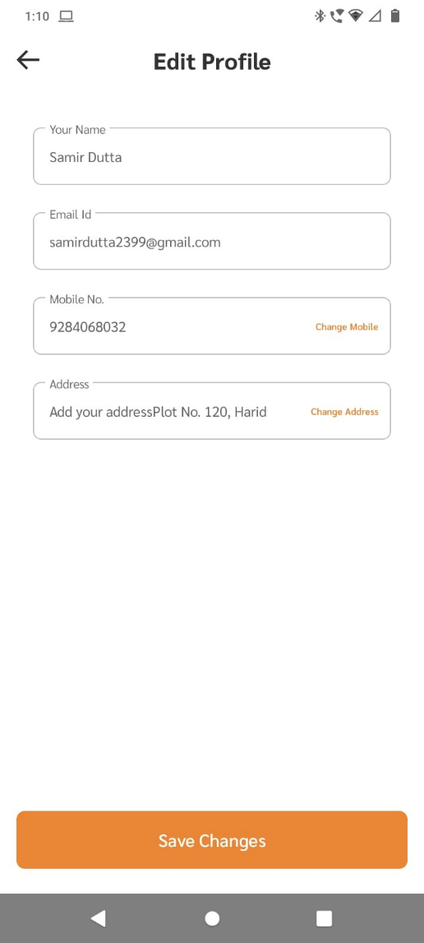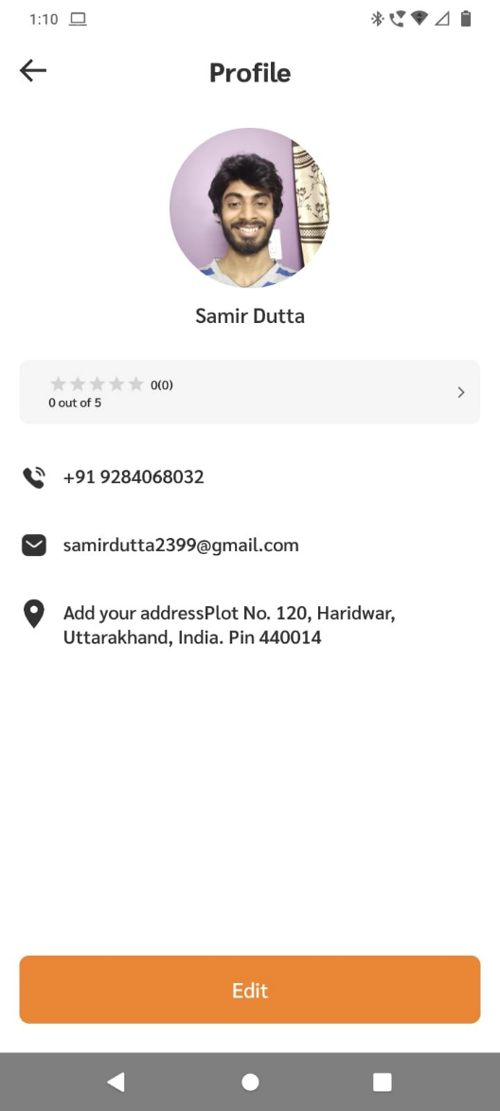

## Overview of Home Page

When you open the application, you will be greeted with this home page with lots of different buttons and features, all of them is explained below.

Menu Button

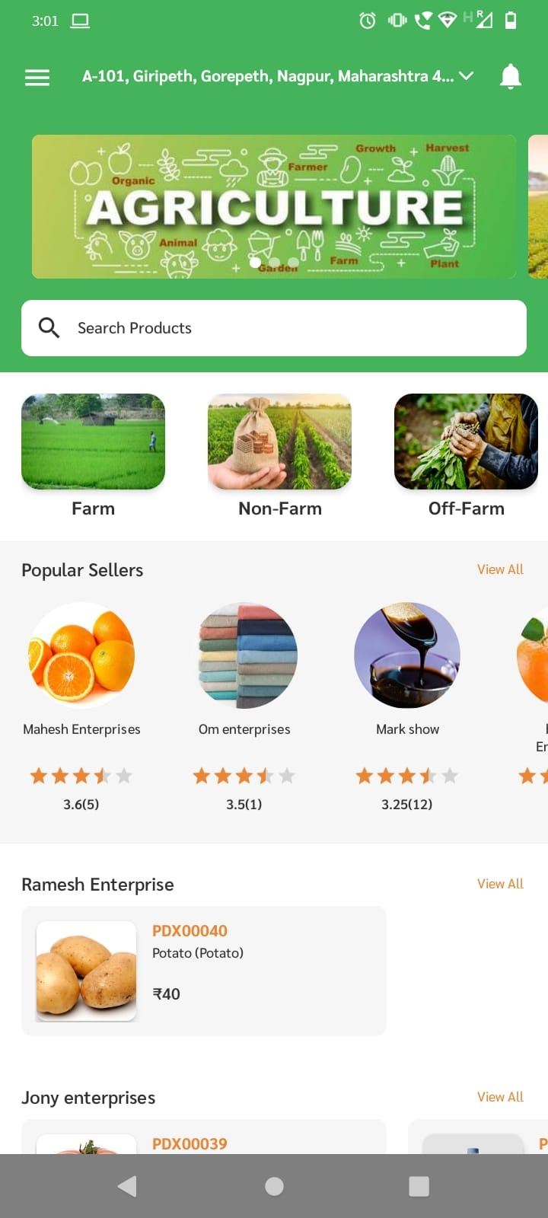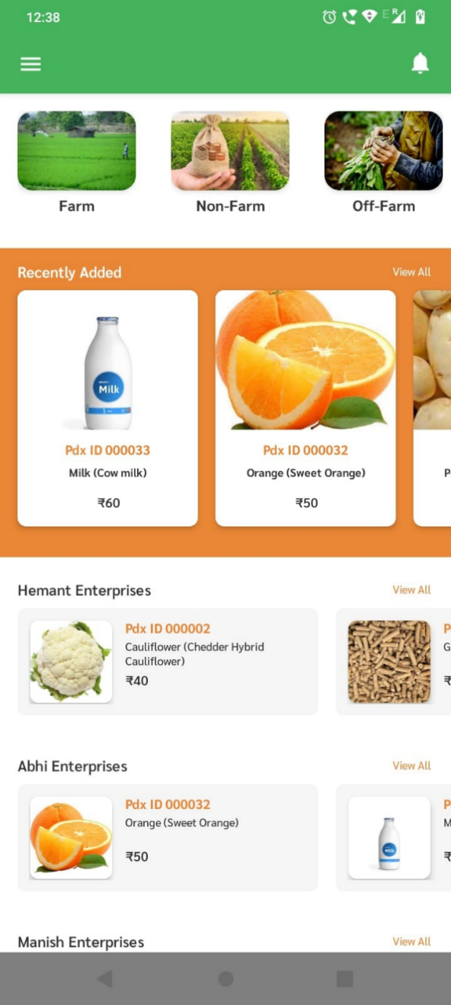

Nearby SHG Enterprise/CLF

Search Box

Main Categories

Popular Sellers

Notification Button

Recently Added Products

# Section 3: Products & Sellers

## Browse Products

There are many different ways to browse products in the platform

* Category wise filter
* Location wise
* Direct Search

Category Wise: In order to view products category wise, follow the steps given below:

Step 1: From the list of main categories click on the category for which you want to view the products

Step 2: list of all the products from that category will be shown.

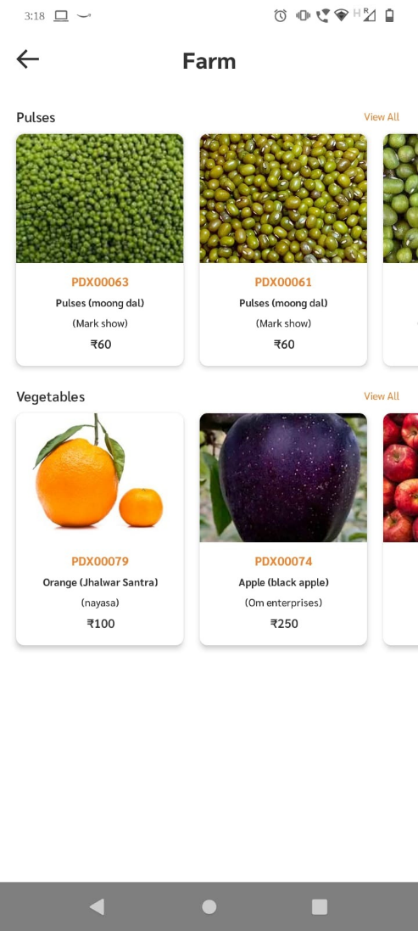



Location Wise: sellers near to your location will be shown in home page

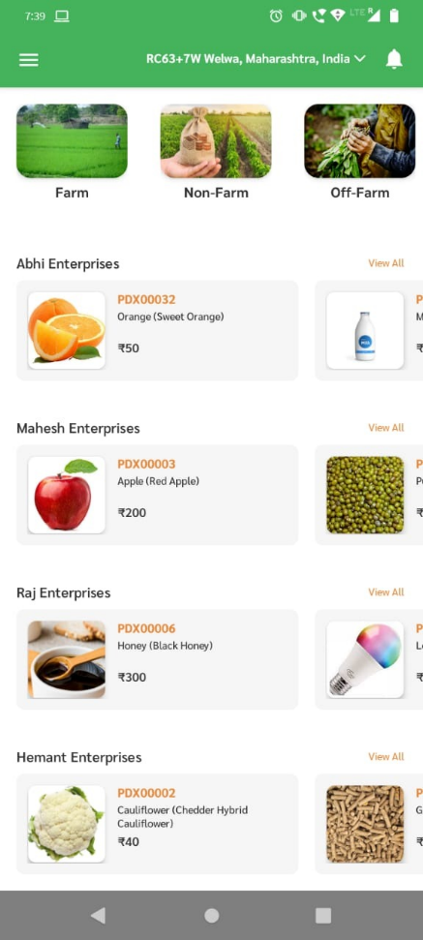

Sellers nearby your location

Direct Search: Users can directly search any product from search bar present at top of home page

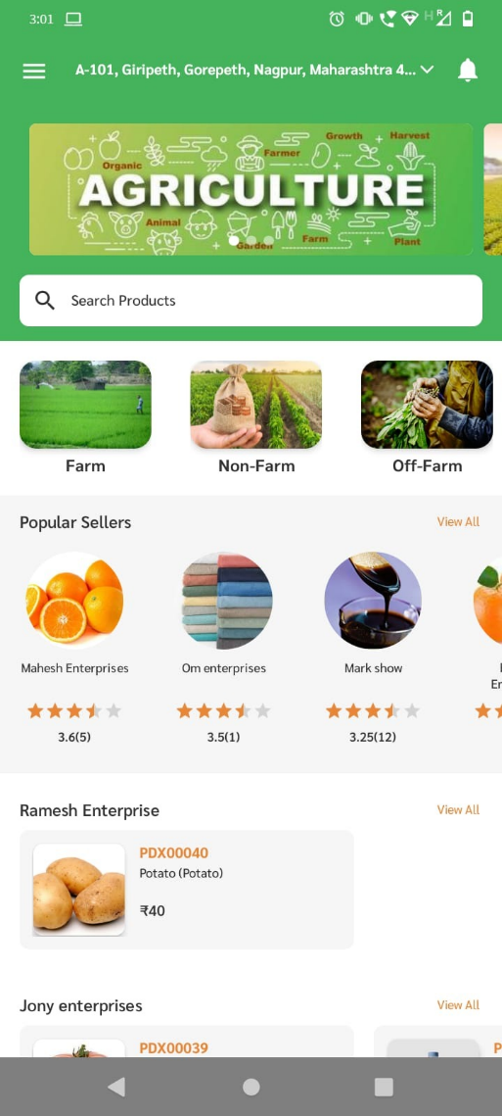

Search Bar

## Product Page

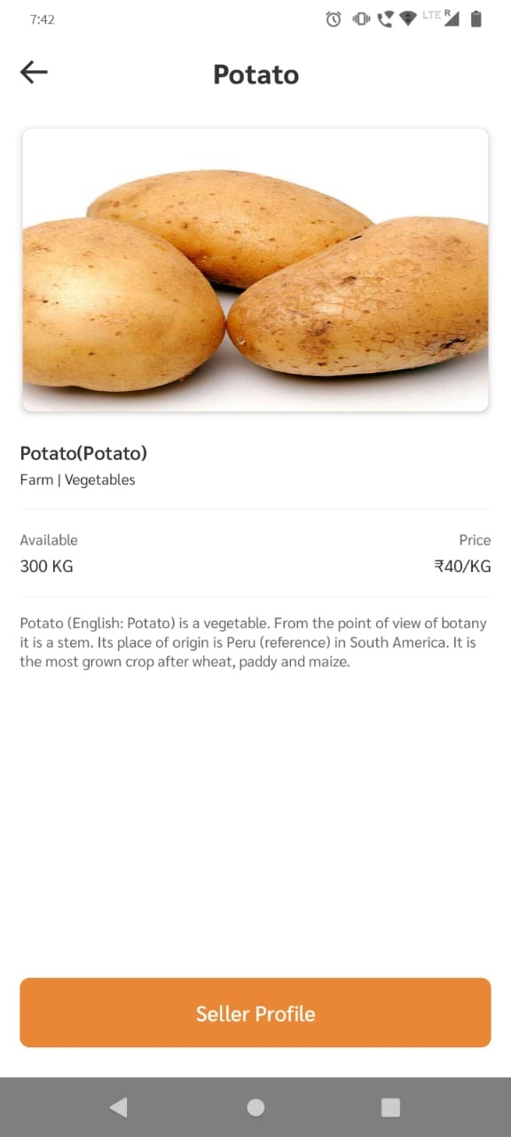

Product Description

Name of the product

Quantity in stock

Product Price with Unit

Product Image

## Express Interest

To buy any product user can place order directly with seller by expressing interest from a seller.

Step 1: Click on the Product you want to express interest for

Step 2: Click on “View Seller” at the button.

Step 3: Click on “Express Interest” button.

OR

Step 1: Click on the Seller from which you want to buy any product.

Step 2: Click on “Express Interest” button.

Step 3: On Express Interest page click on “Add Products” button to add products to view all products from that seller.

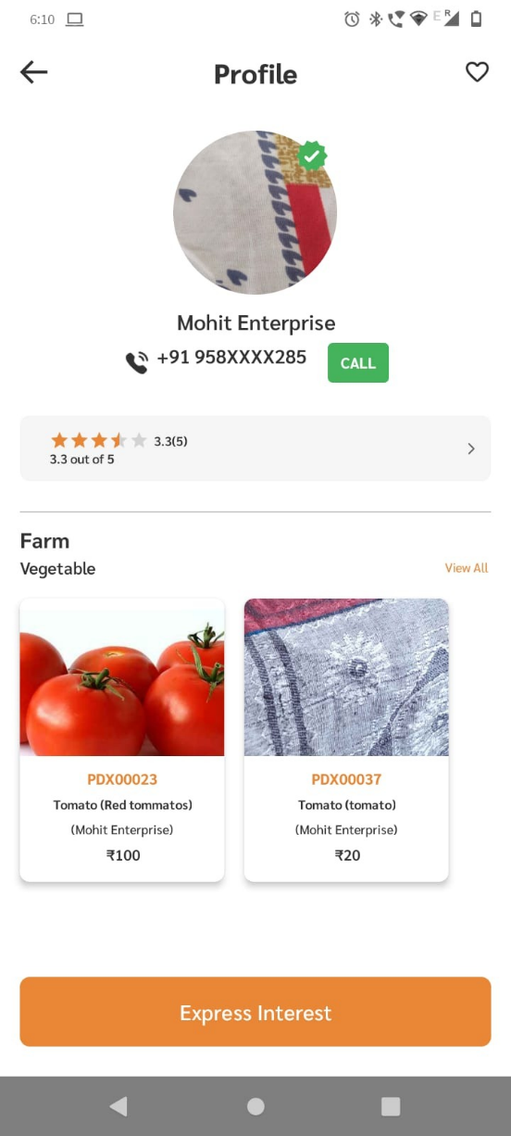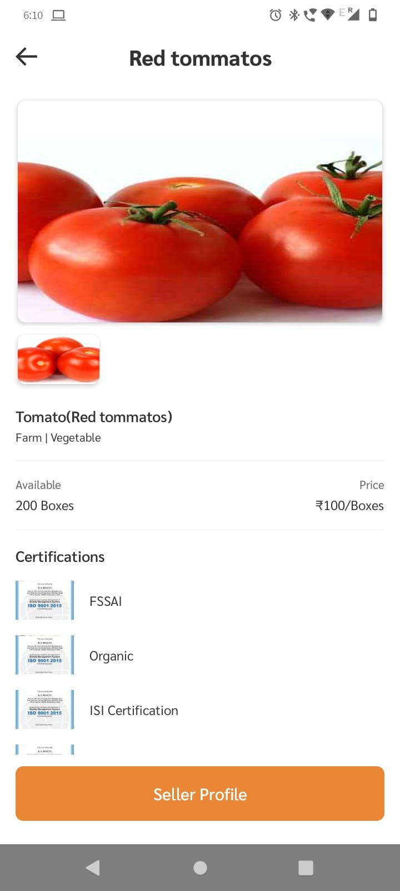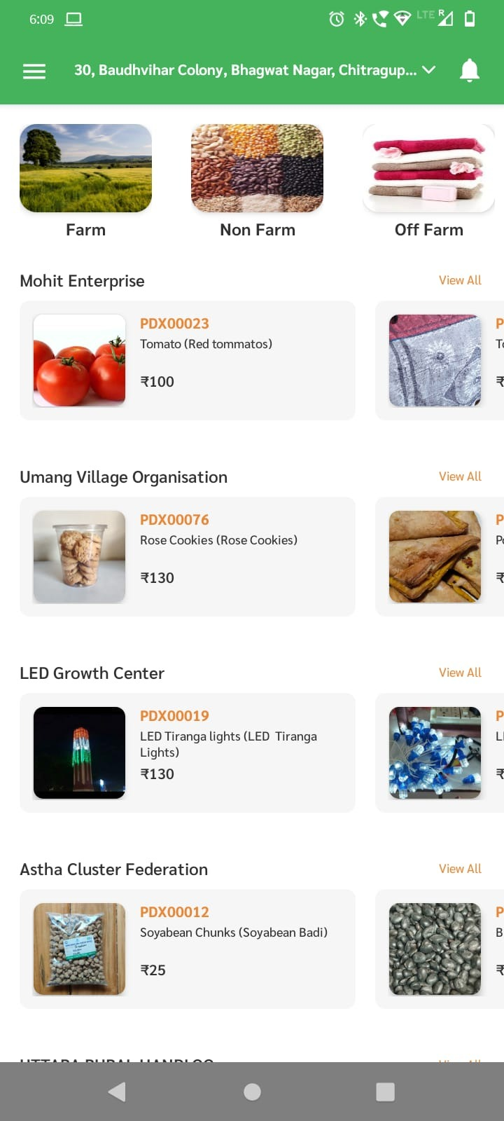

Step 4: Here you will have a list of all products from that seller, Select quantity for the products you want to place order, by clicking “+” or “–“ button and after that click on “Done” button.

Step 5: You will be returned to Express Interest page, and your products will be added along with quantity, here you will have an option to write your queries, instructions directly to seller on Your Message section.

Step 6: Once you are done with your product selection click on “Submit” button.

Your request have been successfully submitted with seller.

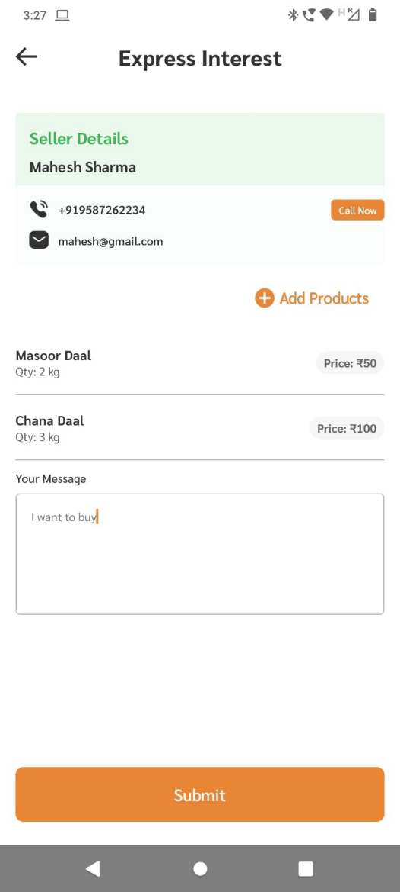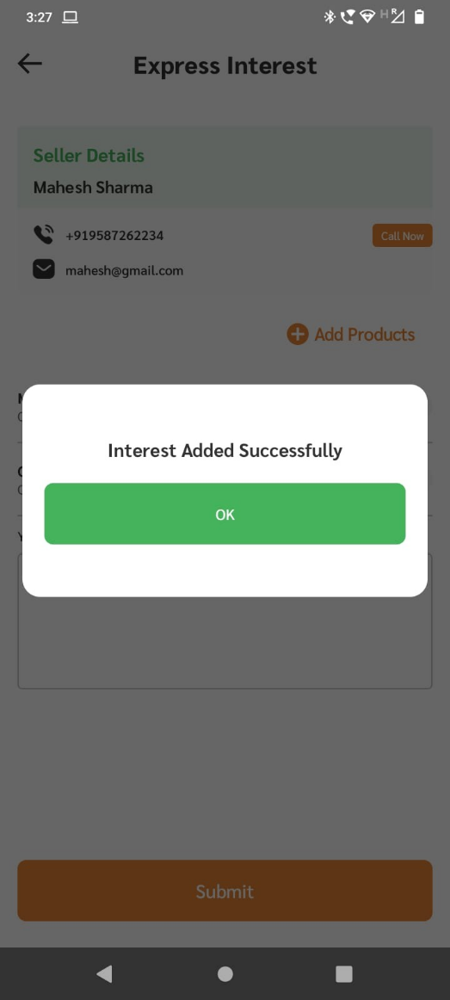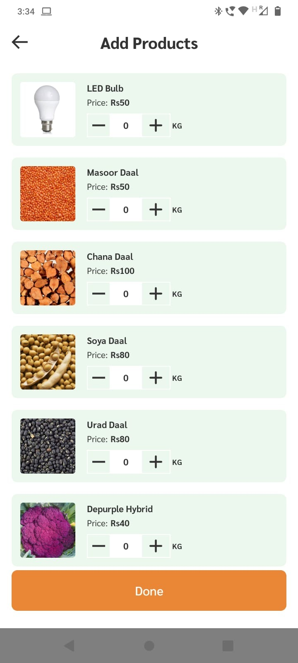

## My Orders

After expressing your interest for the product, If sellers accepts your order, It will be shown under My order. To view your order follow the steps below:

Step 1: From the side menu click on “My Order” button.

Step 2: Under My order you will see list of your order under 2 tabs, Pending and Completed

If your order is delivered then it will move from Pending to Completed.

Step 3:You can click on order to view details, and you can directly call seller by clicking “Call Now” button.

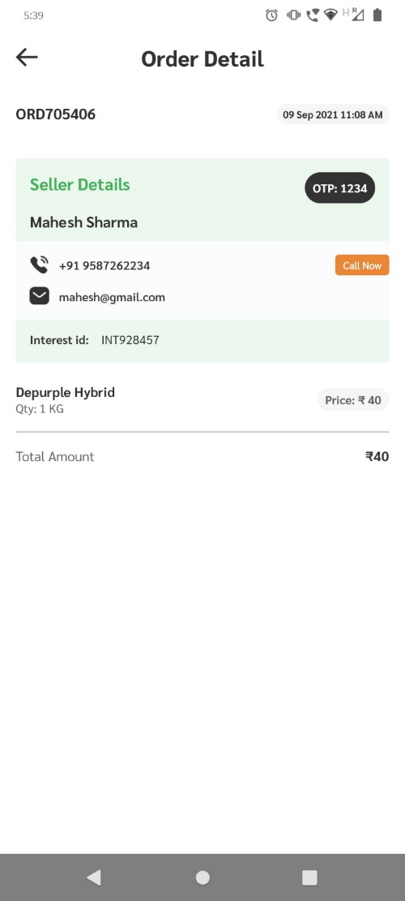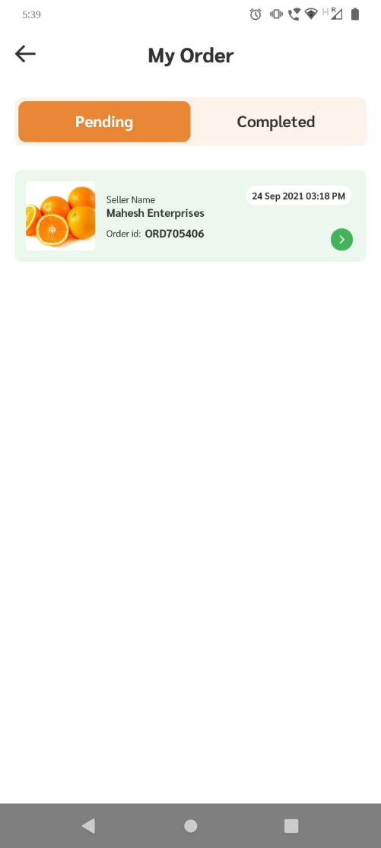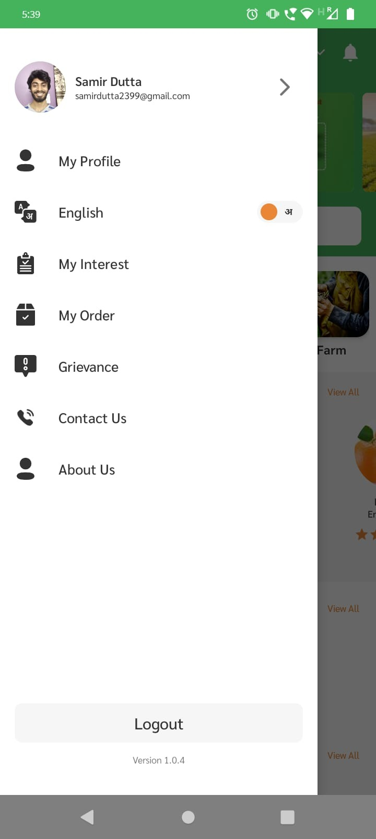

## Seller Profile

To view seller Profile follow the steps below:

Step 1: From the product Page, Click on Seller profile

Step 2: Then you will be redirected into seller’s profile here you can view all the products by that seller, you will also find seller’s contact information including seller’s Phone No and Email Id, as wellas seller’s rating.

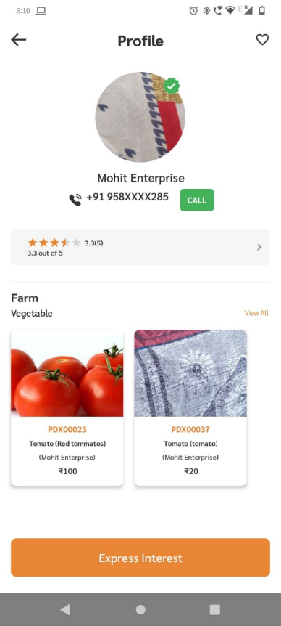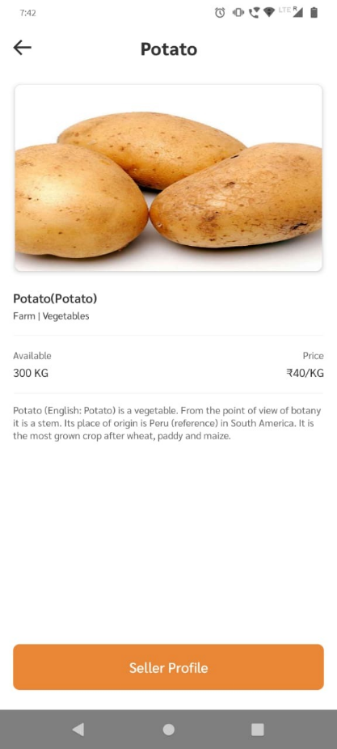

## Ratings and Reviews

To view seller’s rating click on Rating section highlighted below, here you will see the rating of seller in detail.

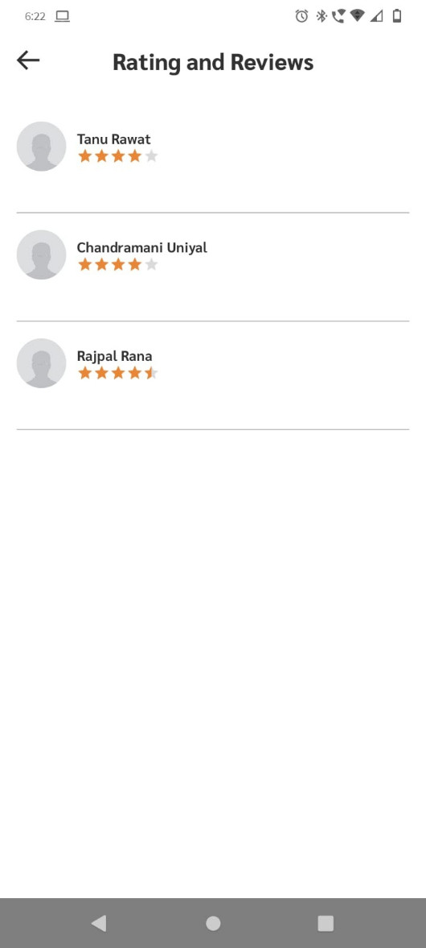

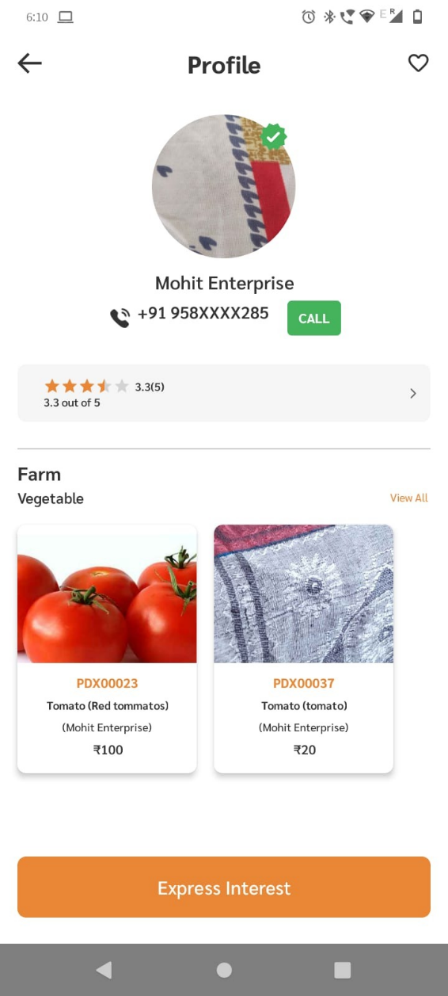

# Section 4. Other Features

## Grievances

In order to raise an issue users can built in grievances section in the app, In order to access grievances follow the steps below:

Step 1: Go to side pane and click on “Grievances”

Step 2: Click on “Raise Ticket” at the button.

Step 3: Select your issue from dropdown, and explain in the text field below

Step 4: Click on “Submit”

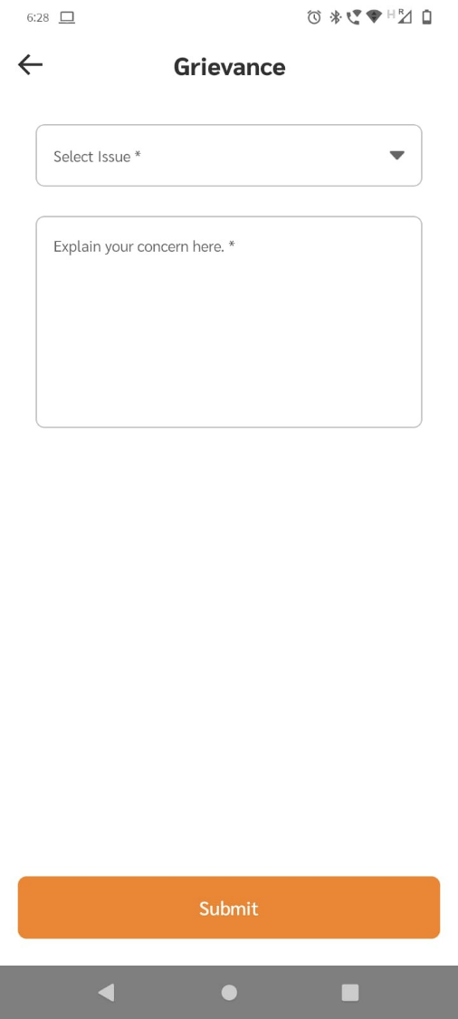

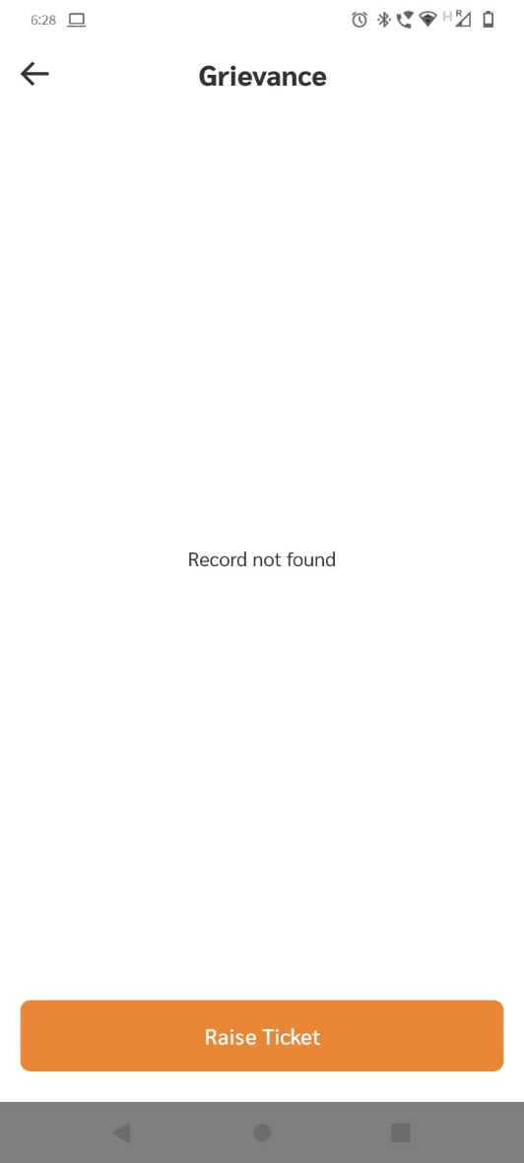

## Ratings Orders

One your order is accepted you can leave a feedback as will as a star rating out of 5 as per your experience:

Step 1: Go to “My order” page as shown in section 3.4 “My order”.

Step 2: Under completed section click on order details

Step 3: Under Order details page you can leave a written feedback as well as leave star ratings out of 5 (5 being the highest)

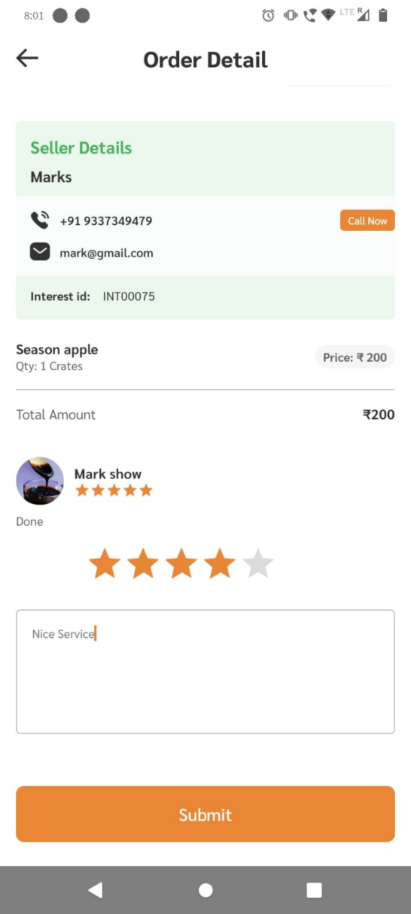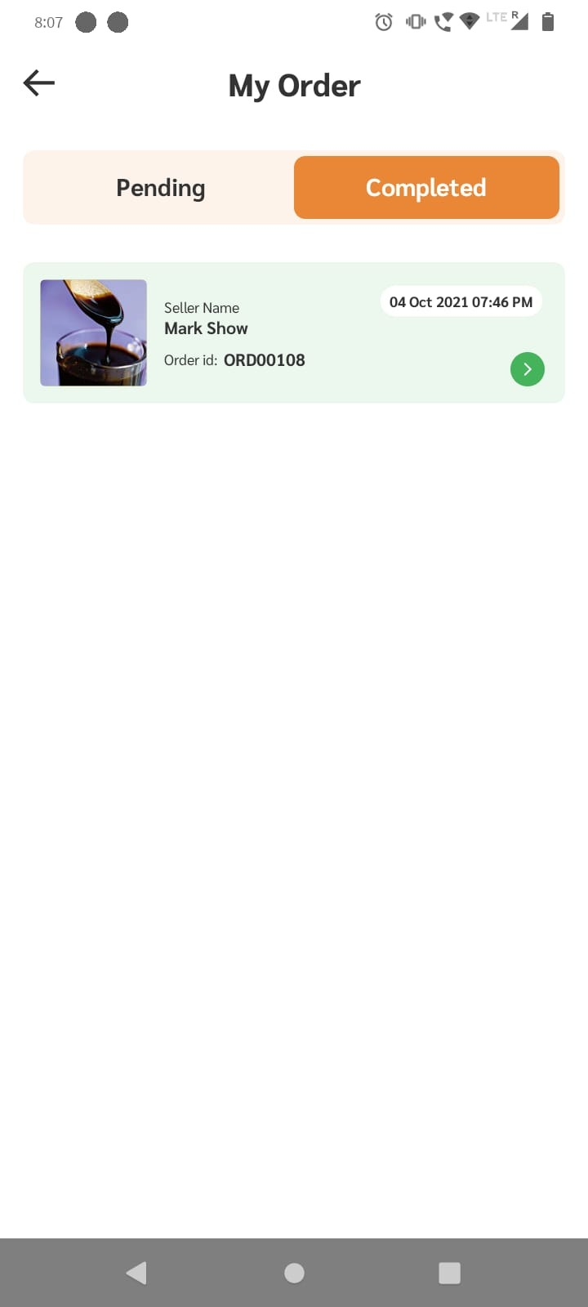

## Notifications

To view all notifications click on “Bell icon” on home page shown below, here you will find list of 10 previous notifications

